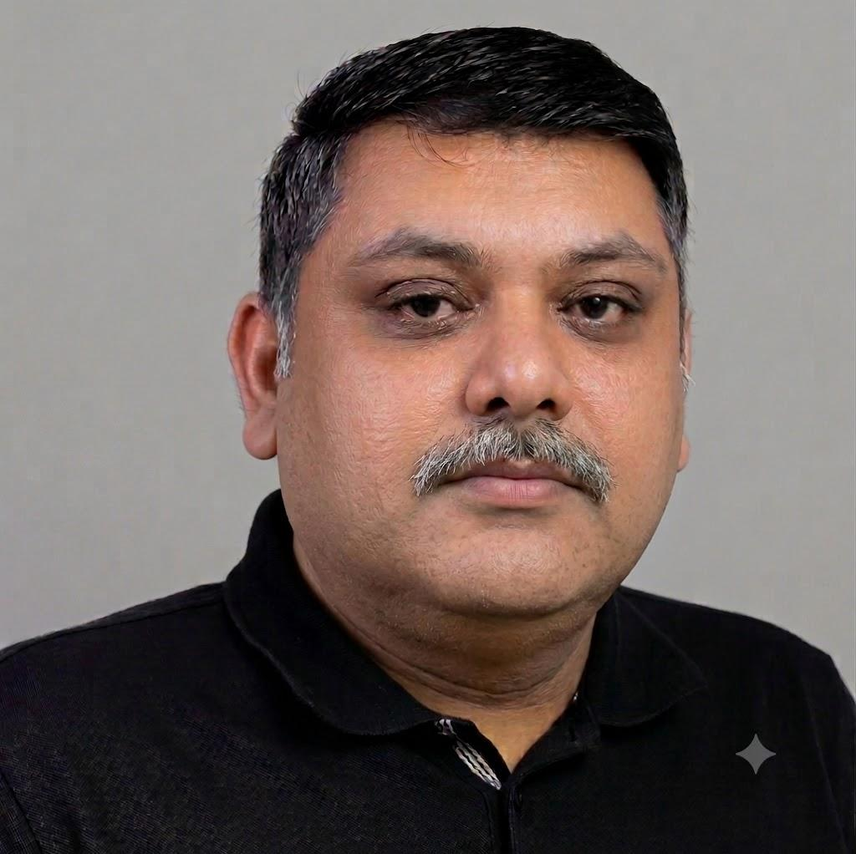 | Ashish Kumar  Software Engineer · Tech Lead · 20+ years  20+ years shipping web platforms — from hospitality systems to fixed wireless operator tools.  ashish@ashishku.in · +919405577151  https://www.linkedin.com/in/ashish-kumar-22752a19/ · https://www.github.com/ashishku

ABOUT
I am a passionate software engineer with 20+ years of experience. I lead frontend architecture, mentor engineers, and ship operator and device experiences that stay fast under real-world load. Outside work I photograph, tinker with electronics, build PCs, and chase DIY projects.

SKILLS
JavaScript — 14+ years across React, Angular, Backbone, and Knockout.
Node.js — 7+ years building services and tooling with custom frameworks.
TypeScript — Typed web applications and shared frontend platforms.
React — React and React Native (Expo) for web and mobile surfaces.
AngularJS — Production experience with AngularJS 1.5 applications.
Linux — Daily driver OS; comfortable with bash and shell automation.
Git — GitHub and GitLab workflows, reviews, and branching strategy.
Perl — Web apps and crawling systems across long-running products.
Python — Practical scripting and tooling with Python 2 and 3.
Travel & Hospitality — Domain depth plus IATA/UFTAA Consultant certification.

JOURNEY
Tech Lead — Tarana Wireless, Inc.
Jul 2021 – Present · Remote
Tarana delivers fixed wireless broadband with higher performance at lower cost for homes and businesses.
- Migrate applications to micro frontends.
- Improve performance of the operator portal and device UI.
- Add i18n, responsive design, and migrate to MUI.
- Introduce Cypress for component integration testing.
- Guide and mentor a small US-based team.
- Review code and design.
Principal Consultant — Sincro, an Ansira company
Sep 2020 – Jun 2021 · Pune
Digital Marketing business unit formerly of CDK Global, sold to Ansira.
- Part of the config team for the NextGen platform.
- Lead, guide, and mentor a team of four on JavaScript/Node.js.
- Coordinate with onshore teams on requirements and deployments.
Principal Consultant — CDK Global
Sep 2016 – Aug 2020 · Pune
Integrated technology for roughly 30,000 auto and specialty dealers worldwide.
- Part of the CMS team for the NextGen platform.
- Lead, guide, and mentor a team of four on JavaScript/Node.js.
- Coordinate with onshore teams on requirements and deployments.
Freelance Consultant — MIOTWEB Technologies
Sep 2014 – Present · Pune
Privately held IT solution providers formed in 2014.
- Train, guide, and mentor teams on JavaScript, Perl, and related tech.
- Help teams with designs and reviews.
Corporate Trainer — Freelance Trainer
2012 – Present · Pune
Corporate training on JavaScript, Perl, and modern web stacks.
- Headway Techies — JavaScript, TypeScript, AngularJS 1.5, React, React Native, Perl basics.
- EduRamp Learning Services — JavaScript, jQuery.
- InnoServ Solutions — JavaScript, Node.js, AngularJS 1.5, Express.
Multiple roles — Cybage Software Pvt. Ltd.
Feb 2006 – Sep 2016 · Pune
Technology consulting specializing in outsourced product engineering.
Technical Architect (Apr 2012 – Sep 2016)
- Guide and mentor JavaScript and Perl engineers across Cybage.
- Estimations and proposals for clients and prospects.
- System design, web performance, interviews, and training.
Project Manager (Oct 2010 – Apr 2012)
- On-time delivery across three teams (22 people).
- Act as Scrum Master; review code, design, and tests.
- Team appraisals and stakeholder management.
System Analyst (Apr 2009 – Oct 2010)
- Lead development for a team of eight.
- Requirements, design, reviews, and client updates.
Sr. Software Engineer (Apr 2007 – Apr 2009)
- Lead a team of six through delivery.
- Requirements, design, code review, and development.
Software Engineer (Feb 2006 – Mar 2007)
- Requirements, code review, and feature development.

PROJECTS
Operator Portal
Tech Lead · Jul 2021 – Present
TCS web portal for ISPs to monitor network health, metrics, and diagnose issues on individual devices.
Device UI
Tech Lead · Jul 2021 – Present
Compact web app hosted on network devices for configuration and debugging.
NextGen Config
Developer · Sep 2016 – Jun 2021
Node.js next-generation website platform tools that help dealers build and configure sites.
BodyLog 365 LifeSmart
Freelance Consultant · Jun 2015 – Nov 2015
Reports and charts for LifeSmart health devices with doctor/pharmacist chat.
My LifeSmart
Freelance Consultant · Nov 2015 – Dec 2015
Commerce site for LifeSmart products and app subscriptions; custom markdown static site builder.
Cybage Technology Group
Technical Architect · May 2012 – Sep 2016
Architect group guiding a virtual community of developers through design and mentoring.
MIS
Technical Architect · Sep 2014 – Sep 2016
Migration of an internal MIS application onto a modern technology stack.
123insight
Technical Architect · Nov 2013 – Feb 2014
End-to-end manufacturing ERP covering quoting, CRM, sales, purchasing, stock, and invoicing.
Web 3.0
Technical Architect · Nov 2011 – Dec 2012
TravelClick hotel reservation solution and website tooling for hoteliers.
GuestView, Rate360, OrderManager
Project Manager · Oct 2010 – Oct 2011
Guest management and business intelligence suite for hotel revenue operations.
PricePosition & HotelConfig
Project Lead · 2006 – 2010
Business intelligence products for Rubicon, later evolved under TravelClick.
Farelogix
Project Lead · Jul 2007 – Oct 2008
Distribution technology lowering unit cost of distribution for airlines and travel sellers.

EDUCATION & ACHIEVEMENTS
Graduation
Bachelor of Technology (B.Tech) in Information Technology from Uttar Pradesh Technical University, 2004.
Diploma in Advanced Computing (DAC)
CDAC (Bytes Infosys), Delhi, 2006 — Best Student award.
IATA Certification
IATA/UFTAA Travel and Tourism Training Programme – Consultant (Level 2).
Trainer recognition
Multiple recognitions for training experienced engineers and freshers across AngularJS, Backbone, Node.js, Knockout, Ember, jQuery, CasperJS, Perl (Moose, P5EE, POE), Python basics, and travel/hospitality systems (GDS, PMS).

